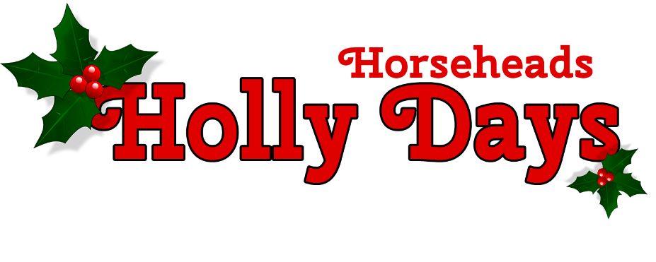
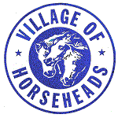
Dear Friend and Neighbor,
Although summer days are still with us, plans for the 34th annual Horseheads Holly Days are coming together already.
Holly Days will be held on Saturday, November 24th in historic Hanover Square.
Once again, the afternoon will feature live dance and vocal performances on center stage, horse & carriage rides, craft and food vendors, the lighting of the Christmas tree and of course, Santa & Mrs. Claus to delight young and old alike.
We need your help to make this year’s Holly Days a hit!
Your financial support as a sponsor will help continue this community event, support the Village activities for area residents, and bring more visitors to the Village of Horseheads to shop and eat at local establishments.
Your tax-deductible donation at one of the sponsor levels outlined on the back of this letter will remain local and help offset costs of the event and the family activities.
Please show your support by completing the section below and remit this form and payment to:
Village of Horseheads Parks & Recreation
Attn: Holly Days
202 S. Main St.
Horseheads, NY 14845

For any questions, contact Nate Nagle, Parks & Rec Department at nnagle@Horseheads.org or (607) 739–5691.
Thank you!
The Holly Days Committee

YES! I want to support the Village of Horseheads Holly Days with a sponsorship of _________________ in the amount of $_______.
Horseheads Holly Days Sponsorships
Stage Sponsor $500
Your company logo and name will be shown on large banners on the stage during the event, be mentioned in all advertising including radio and social media advertisements, and mentioned during hourly announcements at the event.

50/50 Raffle $200
One of the fundraising activities at Holly Days is the 50/50 raffle. Tickets are sold throughout the Village at local businesses during November and at the event. Your company logo and name will be printed all al the 50/50 raffle tickets. Last year over 500 tickets were sold.

Lottery Wreath Sponsor $100
One of the fundraising activities at Holly Days is the annual Lottery Wreath sales. The pine wreaths are donated and adorned with cash and lottery tickets. Your company logo and name will be included in the Lottery Wreath. Raffle tickets for the wreaths are sold throughout the weeks leading up to the event and during the day.

Coloring Contest Sponsor $100
Kids and adults can participate in a coloring contest in the weeks leading up to Holly Days. Winners are chosen and displayed in local storefronts at the event. Your company name and logo will be printed on the coloring sheets and entry boxes at local businesses.

Horse & Carriage Sponsor $150
Your company logo and name will be displayed at the pickup area of the Horse & Carriage rides, which go throughout the Village during the event.

Santa & Mrs. Claus Sponsor $50
Your company logo and name will be displayed at the Santa & Mrs. Claus location, typically in a local storefront in historic Hanover Square. Hundreds of kids and their families visit them during the event.

